**Dashboard link->**

[**To See Wortking of Dasshboard Click Here**](https://public.tableau.com/views/Book3_17246082424940/SUMMARY?:language=en-US&:sid=&:redirect=auth&:display_count=n&:origin=viz_share_link)

**DASHBOARD 1-[SUMMARY]**

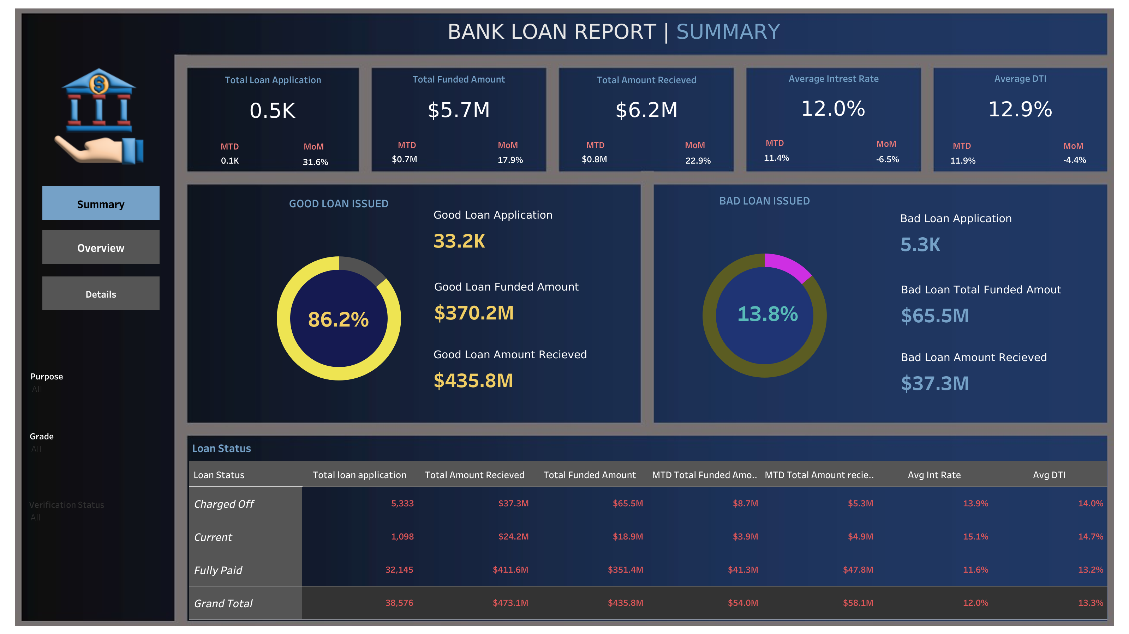

**DASHBOARD 2-[OVERVIEW]**

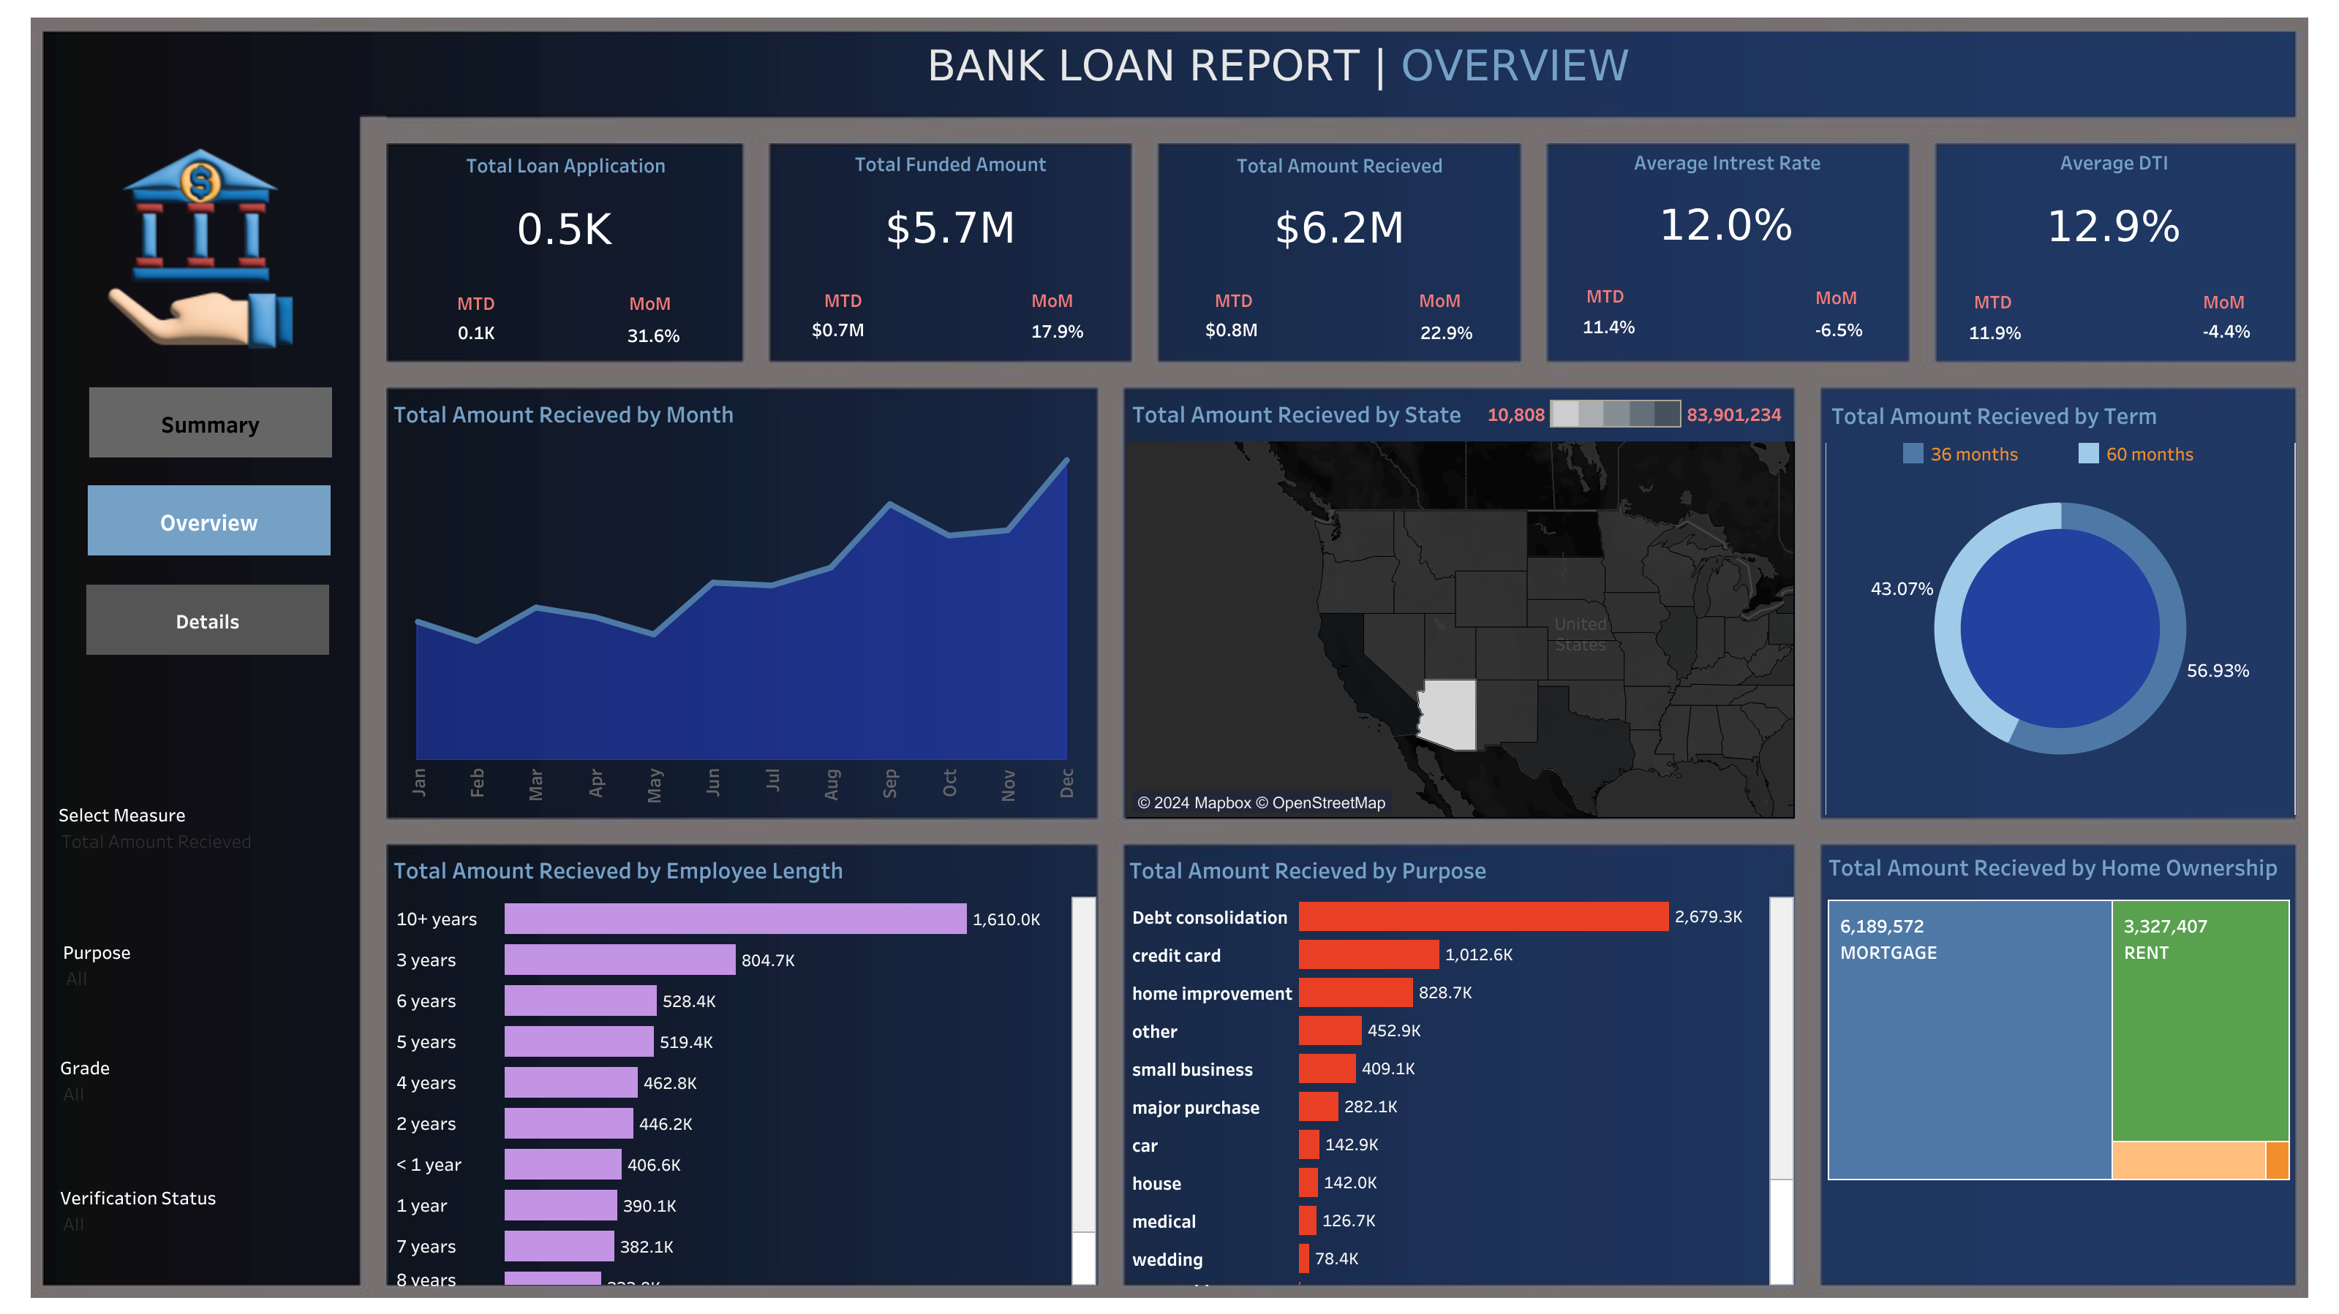

**DASHBOARD 1-[DETAILS]**

